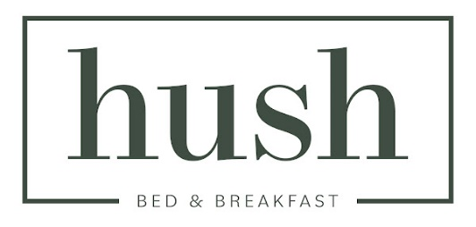

Dear [Guest Name],

Welcome to Hush Bed & Breakfast in Helmond! We are pleased to welcome you and hope you enjoy a comfortable and relaxing stay at the **Hush Poolhouse 2**. If you have any questions or need sightseeing tips, please do not hesitate to contact us. We are always there for you.

Below you will find the instructions for collecting your room key:

 

Instructional video Finding lockers Hush Poolhouse 2 Vault instruction

***After your stay, the key must be put back in the safe.***

Enjoy your stay!

Kind Regards,

Ashraf & Nana

Hush Bed & Breakfast

[info@hushbb.nl](mailto:info@hushbb.nl)

+31615553646

Hortsedijk 15,

5708 HA, Helmond

](https://www.instagram.com/hushbedbreakfast/)